

“Cultural Yarns to Refocus Direction”
MENTOR REGISTRATION FORM
Mentor details:
First name:
Surname:
Email:
Address:
Phone number:
Gender:

MENTOR CONSENT: to share information with Youth Justice and Kambu Health
I understand that the CYRD program is a community lead program through Youth Justice, I give Kambu permission to share the enclosed information with Youth Justice for the purpose of data collection and ongoing Mentor opportunities in reference to the CYRD program.
Mentor signature: Date: / /

Do you identify as: Aboriginal Torres Strait Islander or Both

Neither Please list___________________________________________________________________________

Clan / language group if known: _____________________________ Area: ________________

Interests/Hobbies/Life skills/Career Highlights: ______________________________________________________________________________

______________________________________________________________________________

_______________________________________________________________________________

_______________________________________________________________________________

DIETARY
Dietary requirements: Vegetarian Gluten-free Dairy-free
Please list other dietary requirement if not listed above:

HEALTH ISSUES we need to be informed about? This allows event organisers to better respond to your needs in the event of an incident.
IN CASE OF AN EMERGENCY please list your next of kin
Name
Relationship to you
Contact Number/s
Mobility
Do you have access limitations? Yes No – if yes, please indicate what support is required
Blue Card
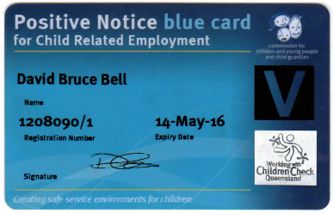
Queensland Government - Working with Children’s ‘Blue Card’.

It is essential to have a copy of your blue (V,P) card prior to the engagement in CYRD.
Availability
When will you be available for programs?
Days per week: | Times From: | Times To:
Monday
Tuesday
Wednesday
Thursday
Friday

